**Goniostat for the Tormek**

**Instructions for**

**Building**

**Version 1**

**11 August 2024**

This document is intended to you print and build the goniostat jig for use with a Tormek.

If you have any questions, please contact me at [ColvinTools@Gmail.com](mailto:ColvinTools@Gmail.com).

Good luck.

Rich Colvin

Table of Contents

Bill of Materials 4

3D Printing the Parts 5

Assembly of the Goniostat 7

Using the Goniostat 9

Document Version History 12

|  |
| --- |
| Bill of Materials |

Parts required for building this are below. The item numbers are shown in the following drawings using an orange, circled number like the one to the right.

**NOTE:**  Pictures shown in the table below are to help with identification. Sizes shown are not representative of the actual size.

| Item # | Item | Qty | Source | Source  Part Number | Comments |
| --- | --- | --- | --- | --- | --- |
| 101 | **Short-Thread Alloy Steel Shoulder Screw**  6 mm Shoulder Diameter, 4 mm Shoulder Length, M5 x 0.8 mm Thread | 1 | McMaster-Carr | 94361A517 | For the tool fence |
| 102 | **Black-Oxide Steel Machined Neck T-Slot Bolt**  M6 x 1 mm Thread, 28 mm Thread Length, 6 mm Wide Slot | 1 | McMaster-Carr | 92770A113 | For the tool fence |
| 103 | **Steel Knurled Grip Knob**  M6 x 1mm Threaded Through Hole, 25mm Diameter Head | 1 | McMaster-Carr | 60765K333 | For the tool fence |
| 104 | **Black-Oxide Steel Knurled Grip Knob**  M6 x 1 mm Thread 19mm Long Stud | 1 | McMaster-Carr | 61165K73 | For the tool fence when using the depth stop |
| 105 | **Flat-Tip Set Screws**  M6 x 1 mm Thread, 5 mm Long | 1 | McMaster-Carr | 93245A125 | For the tool holders  Box of 50 |
| 106 | **Flared-Collar Knurled-Head Thumb Screw**  M6 x 1.00 mm Thread Size, 14 mm Long | 1 | McMaster-Carr | 99607A292 | For the tool holders |
| 107 | **Tormek SVD-110 Tool Rest** | 1 | Tormek dealer | SVD-110 |  |
| 108 | **Tormek WM-200 AngleMaster** | 1 | Tormek dealer | WM-200 |  |

|  |
| --- |
| 3D Printing the Parts |

|  |  |
| --- | --- |
| **Base Plate** | A blue rectangular object with a curved line  Description automatically generated  Print with this side down |
| **Tool Fence** | A red object with holes  Description automatically generated  Print with this side up |
| **Depth Stop – 15mm** | A yellow object with a hole in the middle  Description automatically generated  Print with this side down |
| **Depth Stop – 25mm** | A yellow object with a hole  Description automatically generated  Print with this side down |
| **Tool Holders**  Slicer (e.g., Ultimaker Cura) should allow for all to be printed at once. | Print standing up vertically. This is the base. |
| **Generic Tool Holders**  Use with 3D CAD (e.g., Autodesk Fusion 360) for any sizes not already defined. |  |

|  |
| --- |
| Assembly of the Goniostat |

Tools needed:

* M6-1.0 tap
* M5-0.8 tap

**Tool Fence**

Tap the center hole using an M6-1.0 tap.

Tap M6-1.0

Tap M5-0.8

**Base Plate**

Tap the center hole using an M5-0.8 tap.

**Tool Holder Lock Down Screw**

For item 102 (Machined Neck T-Slot Bolt), it inserts from the back. You will need to cut down the shoulder so that it does not project above the surface of the base plate. If it does, the tool fence will not sit flat against the base plate.

I used a metal lathe, but a file could also be used.

**Tool Holder Lock Down Screw**

Screwed onto #102

Inserted from the back

|  |
| --- |
| Using the Goniostat |

**Using the goniostat jig with a typical square lathe tool.**

The tool (gray) is held against the tool fence (red). The base plate (blue) slides left and right on the Tormek SVD-110.

The angle used for the tool fence can be set using a typical student’s compass.

The angle for the base plate as it pertains to the grindstone is set using the WM-200.

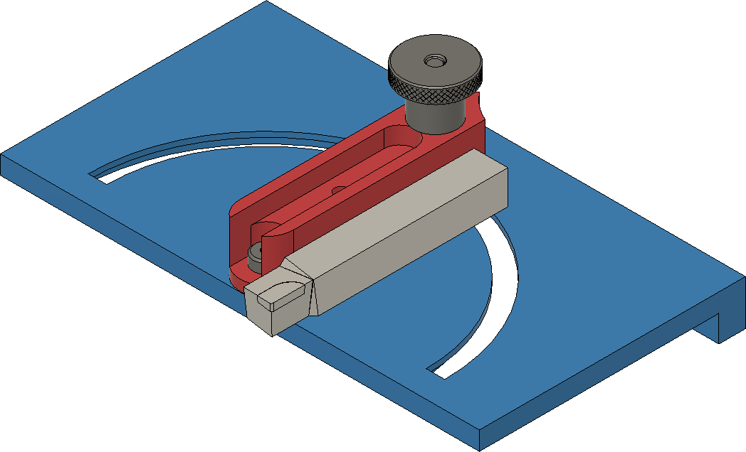

**Using the goniostat jig with a round tool.**

The tool is held in the tool holder (green) using a set screw (#105). The tool holder is held against the tool fence (red). The base plate (blue) slides left and right on the Tormek SVD-110.

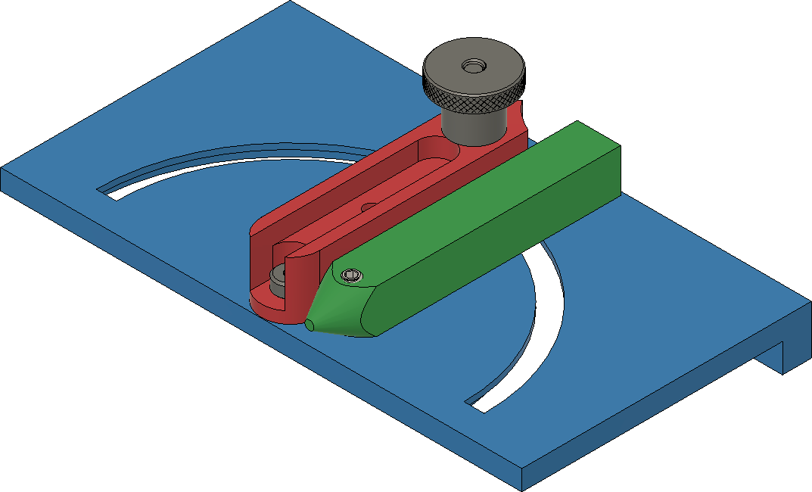

**Using the goniostat jig with a round tool where both wings of the tool need to be equal length.**

The tool is held in the tool holder using the thumb screw, part #106 (this replaces the set screw).

The tool depth stop (yellow) is attached to the tool fence using part #104. The depth of the grind is set by sliding the depth stop to the desired setting and locked down using the thumb screw.

The tool holder (green) is held against the tool fence (red). The base plate (blue) slides left and right on the Tormek SVD-110.

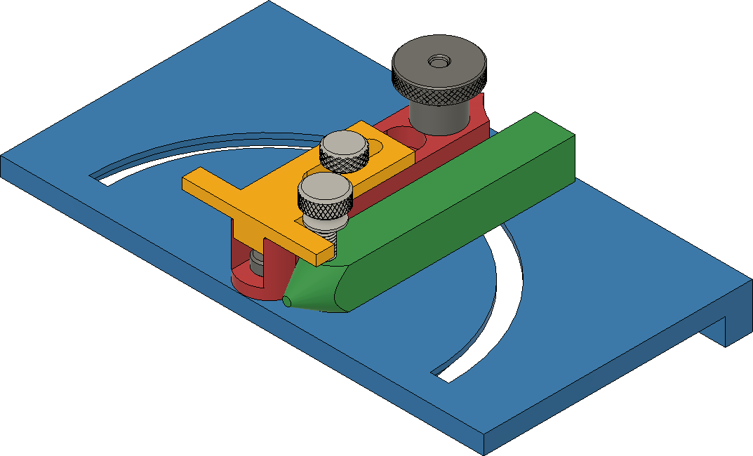

# Document Version History

|  |  |  |
| --- | --- | --- |
| Ver | Date | Comment |
| 1.0 | 11 Aug 24 | Initial document |

To the extent that material may appear to be infringed, I assert that such alleged infringement is permissible under fair use principles in U.S. copyright laws. If you believe material has been used in an unauthorized manner, please contact me at [ColvinTools@Gmail.com](mailto:ColvinTools@Gmail.com).

Permission is not granted to manufacture these for sale.